EXPERIMENT NO. 14
FORK-AND-PULL-REQUEST COLLABORATION WORKFLOW USING
GIT AND GITHUB
AIM
To collaborate on a GitHub project using the fork-and-pull-request workflow: fork a public repository, clone it, create a branch, make changes, push them and raise a pull request for review and merge.
SOFTWARE / TOOLS REQUIRED
- Git (Git Bash)
- GitHub account
- Visual Studio Code
PROCEDURE
Step 1: Fork the Repository
- Open the GitHub website and sign in to your account.
- Navigate to an existing public repository.
- Click the Fork button to create a copy of the repository under your GitHub account.
Step 2: Clone the Forked Repository
- Copy the URL of the forked repository.
- Open Git Bash or the terminal.
- Use the git clone command to clone the repository to your local machine.
- Navigate to the project directory using the cd command.
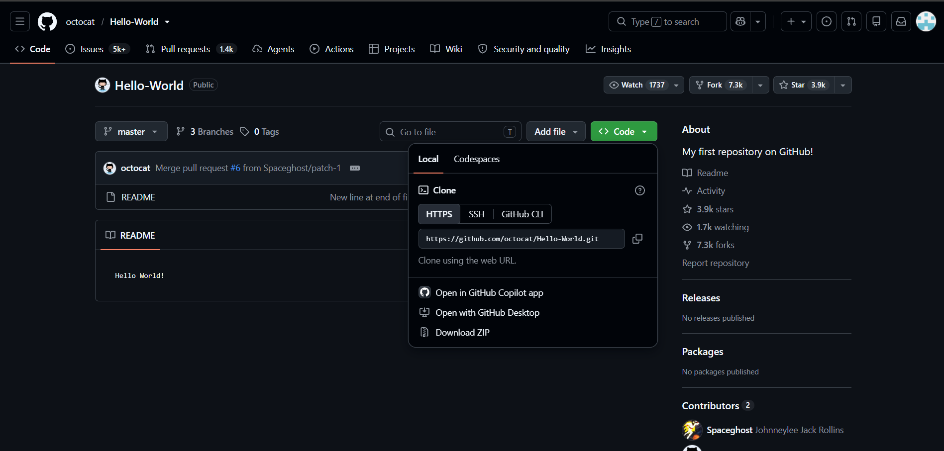
Step 3: Create a New Branch
- Create a new branch using the git checkout -b command.
- Verify that the new branch has been created successfully.
- Switch to the newly created branch before making any changes.
Step 4: Modify the Project
- Open the project in a code editor such as Visual Studio Code.
- Make the required changes, such as adding a new feature, fixing a bug, or updating the README file.
- Save all the modified files.
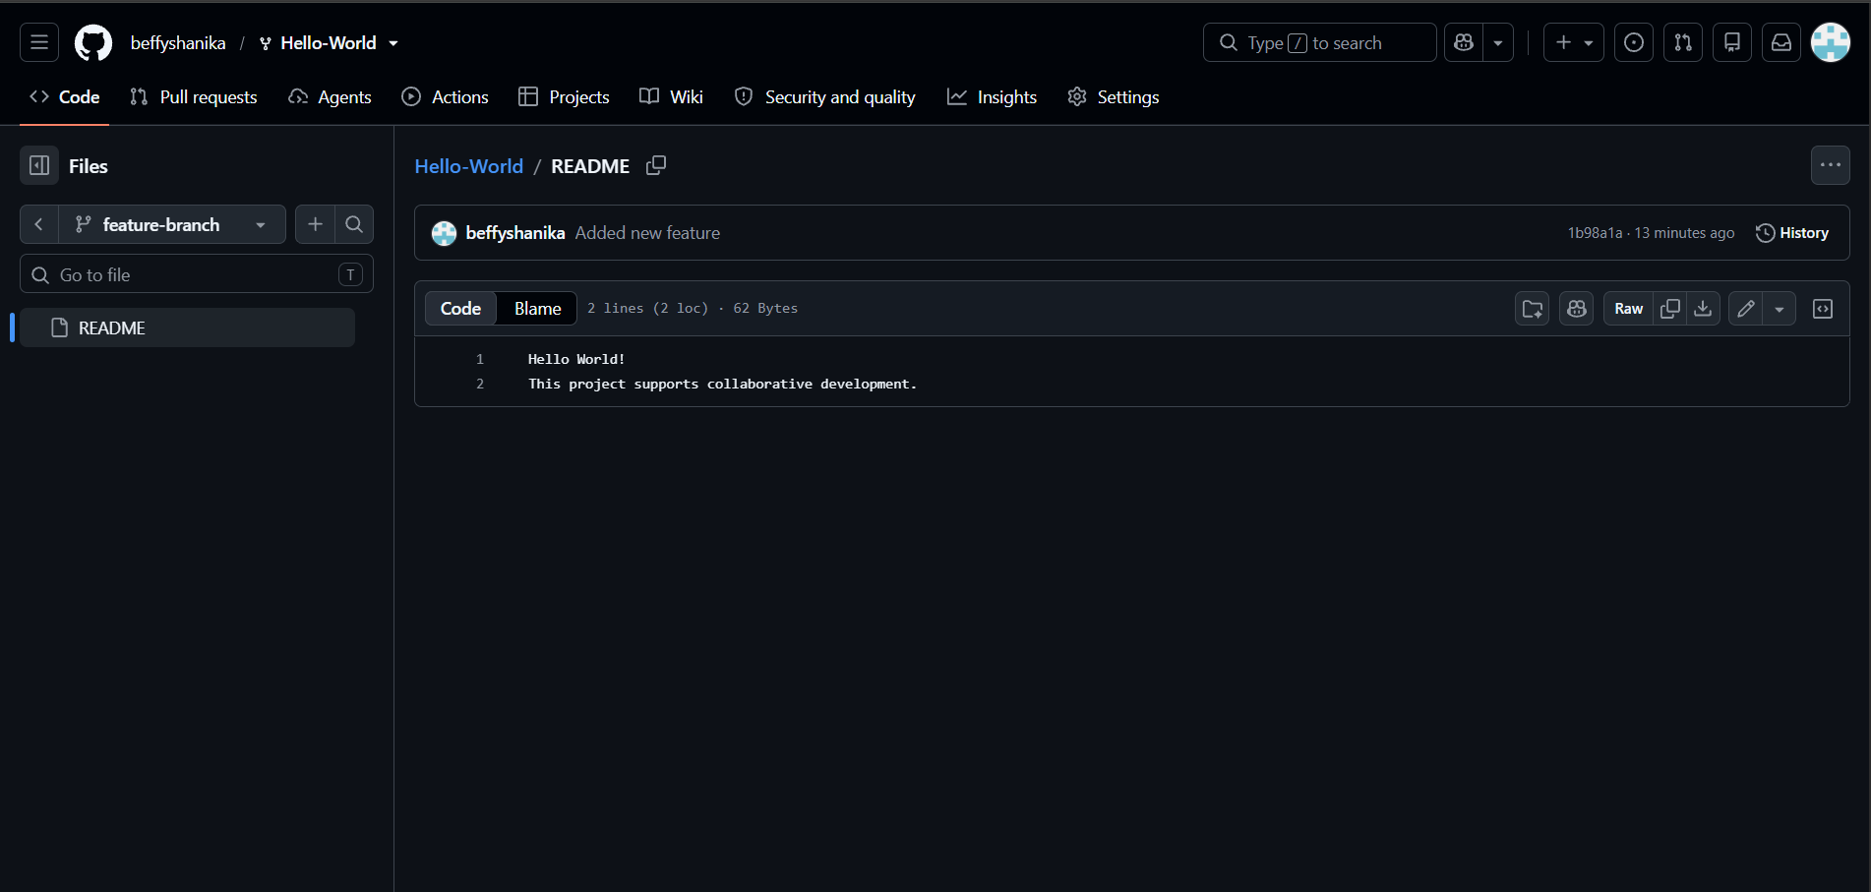
Step 5: Commit and Push the Changes
- Check the modified files using the git status command.
- Stage the changes using the git add command.
- Commit the changes with an appropriate commit message using the git commit command.
- Push the feature branch to the forked GitHub repository using the git push command.
- git status
- git add README.md
- git commit -m &quot;Updated README for collaboration experiment&quot;
- git push -u origin update-readme
Step 6: Create a Pull Request
- Open the forked repository on GitHub.
- Click Compare &amp; Pull Request or New Pull Request.
- Select the feature branch as the source and the main branch as the destination.
- Add a suitable title and description.
- Submit the pull request.
Step 7: Review the Pull Request
- Review the changes shown in the pull request.
- Verify the modified files and commit history.
- Add review comments or feedback if required.
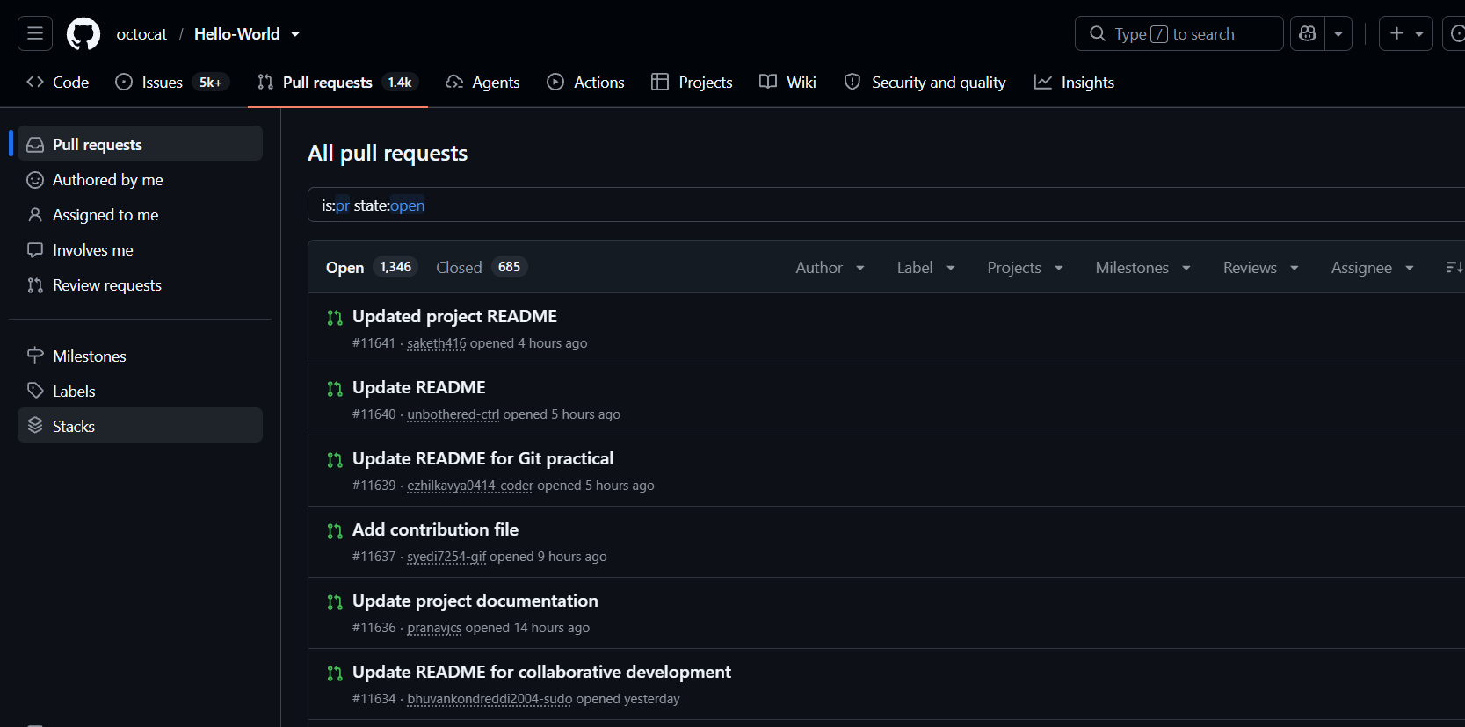
Step 8: Update the Pull Request
- Make additional modifications if feedback is received.
- Commit the updated changes.
- Push the latest commits to the same feature branch.
- Verify that the pull request is updated automatically.
- git add .
- git commit -m &quot;Addressed review comments&quot;
- git push

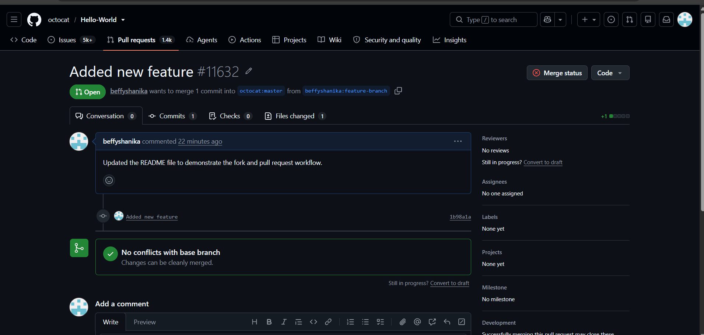
Step 9: Merge the Pull Request
- After the pull request is approved, merge it into the main branch.
- Confirm that the changes have been successfully merged.
- Delete the feature branch if it is no longer required.
Note: GitHub shows “You cannot merge this Pull Request because it targets the original
repository (firstcontributions/first-contributions)”. Only the maintainers of the original
repository can merge it.
Step 10: Document the Work
- Copy the pull request URL.
- Prepare a brief summary of the changes made.
- Submit the pull request link along with the summary for evaluation.
- https://github.com/firstcontributions/first-contributions/pull/122481
EXPECTED OUTPUT
- The repository firstcontributions/first-contributions is forked and cloned.
- A new branch is created, README is updated, committed and pushed.
- Pull Request link: https://github.com/firstcontributions/first-contributions/pull/122481
(merge is done by the maintainers of the original repository).
RESULT
Thus the fork-and-pull-request workflow was demonstrated: the repository was forked, changes were made on a branch, pushed, and a pull request was submitted for review.

